Sales Data Analysis Using SQL
Introduction
The following results were generated using SQL queries after data cleaning and preprocessing. The analysis summarizes customer activity, sales performance, product performance, payment methods, coupon usage, and referral sources.
Table 1 — Overview of the dataTable 1
Average_Cart_Size | Number_of_Customers | Number_of_Orders | Total_Revenue | Avg_Order_Value | Highest_Order | Lowest_Order
5.485 | 1189 | 1200 | 1264761.96 | 1053.97 | 3456.4 | 11.39

Average_Cart_Size | Number_of_Customers | Number_of_Orders
5.485 | 1189 | 1200

Comment: The dataset contains 1,200 orders generated by 1,189 customers, with an average cart size of 5.49 items and an average order value exceeding 1,000, indicating relatively high-value transactions.

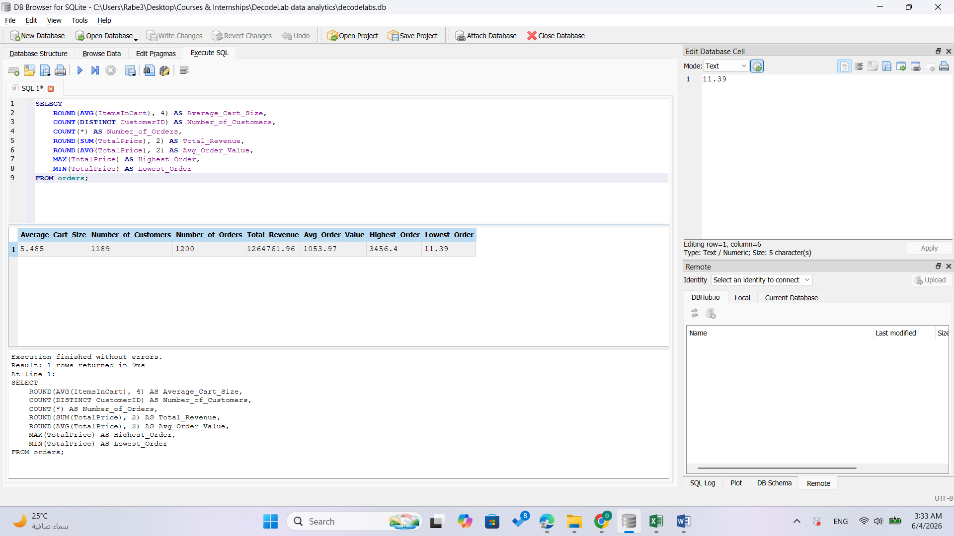
Table 2 — Orders and Revenue by Year
Year | Orders | Total_Revenue | Avg_Order_Value
2023 | 510 | 552643.24 | 1083.61
2024 | 459 | 480235.87 | 1046.27
2025 | 231 | 231882.85 | 1003.82
Comment: Both order volume and revenue declined over the years, with 2023 recording the highest sales activity and revenue contribution.

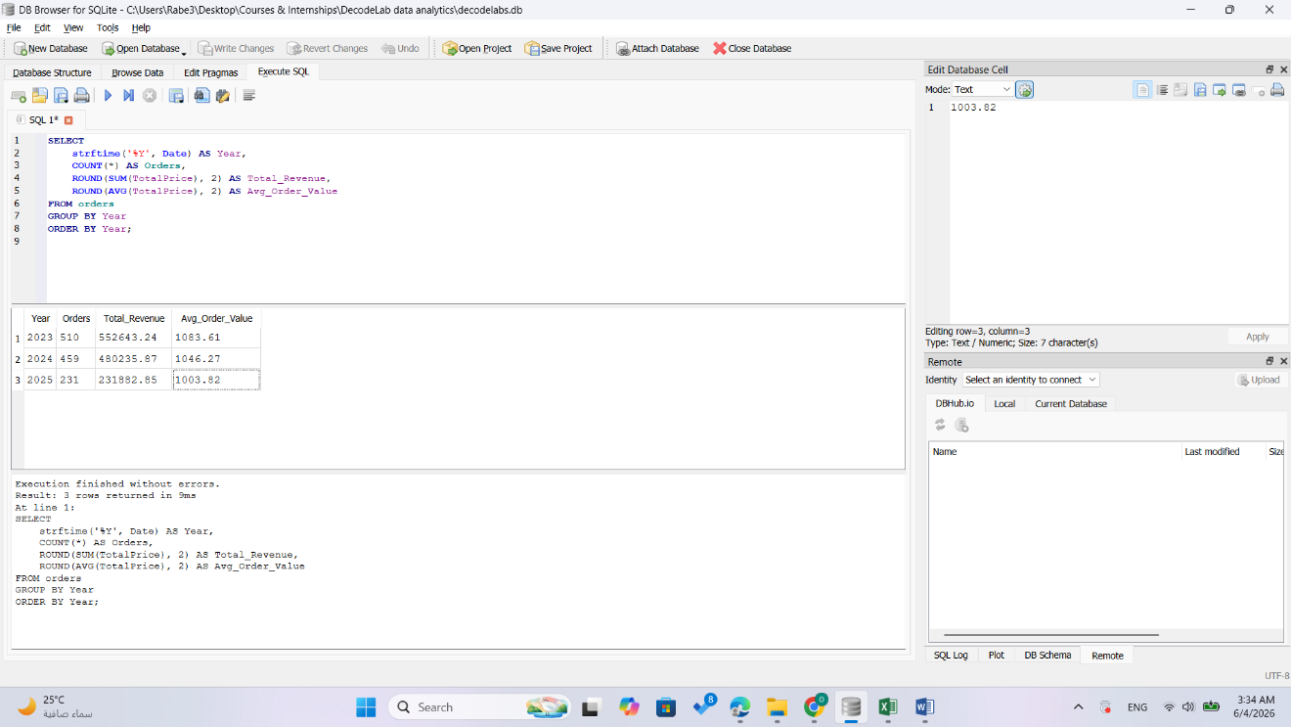

Table 3 — Order Status Breakdown with rates
OrderStatus | Count | Percentage
Cancelled | 250 | 20.83
Returned | 247 | 20.58
Pending | 237 | 19.75
Shipped | 235 | 19.58
Delivered | 231 | 19.25
Comment: Order statuses are distributed fairly evenly, although cancelled and returned orders together account for more than 40% of total transactions, suggesting potential operational challenges.
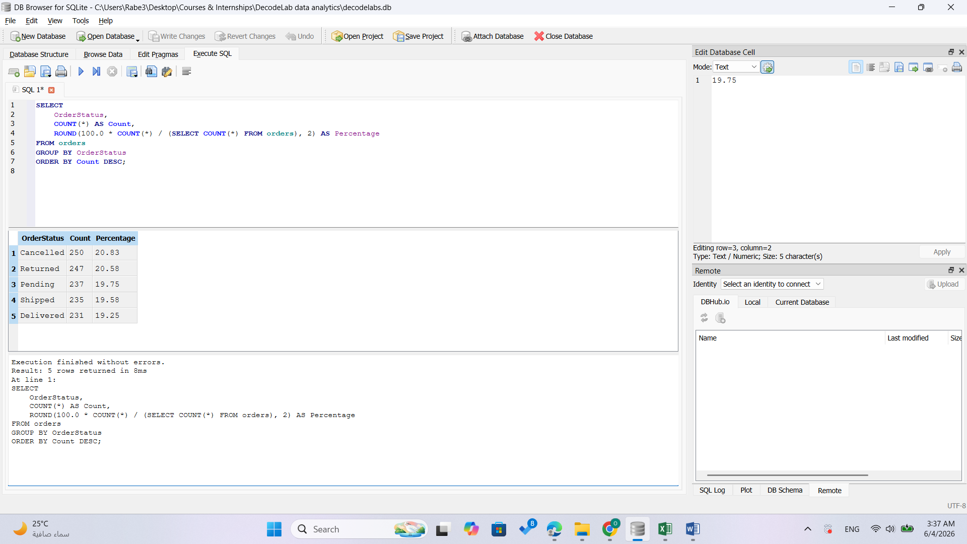
Table 4 — Revenue by Product (Delivered Only)
Product | Orders | Quantity_Delivered | Revenue | Avg_Order_Value
Laptop | 40 | 121 | 40714.43 | 1017.86
Phone | 38 | 101 | 40345.41 | 1061.72
Printer | 29 | 88 | 38054.73 | 1312.23
Monitor | 31 | 96 | 35999.62 | 1161.28
Tablet | 28 | 85 | 31794.52 | 1135.52
Chair | 33 | 105 | 31465.83 | 953.51
Desk | 32 | 94 | 24225.78 | 757.06
Comment: Laptops and phones generated the highest delivered-order revenue, highlighting their importance as key revenue-driving products.
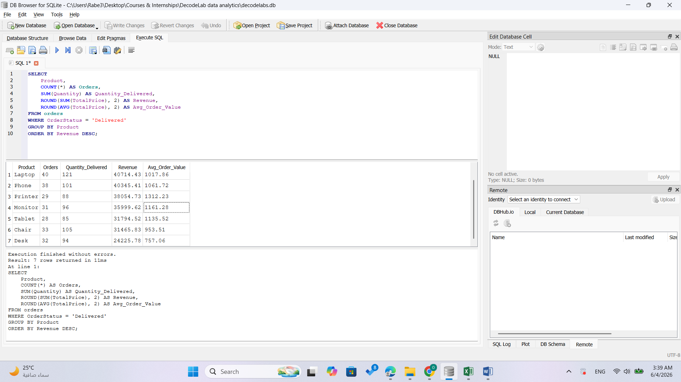
Table 5 — Payment Method Performance (Delivered Only)
PaymentMethod | Orders | Total_Revenue | Avg_Order_Value
Online | 63 | 67119.65 | 1065.39
Credit Card | 43 | 46054.96 | 1071.05
Debit Card | 43 | 45885.14 | 1067.1
Cash | 45 | 42857.69 | 952.39
Gift Card | 37 | 40682.88 | 1099.54
Comment: Online payments generated the highest total revenue, while all payment methods produced relatively similar average order values except for cash transactions.
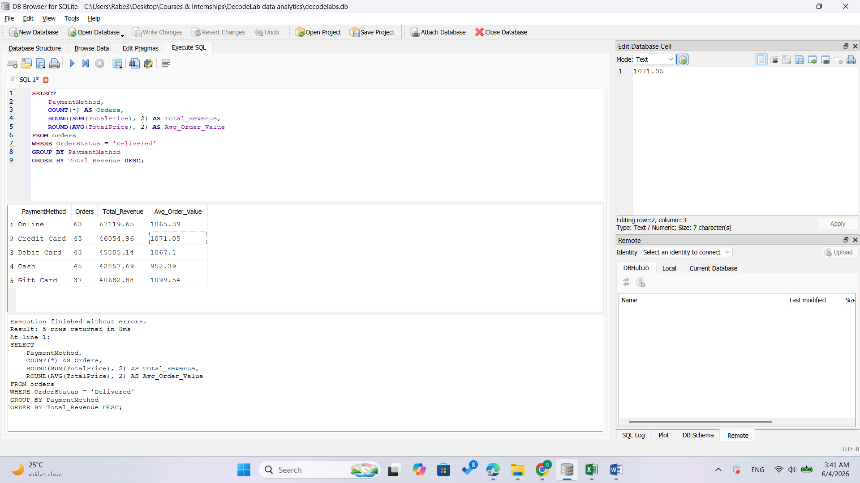
Table 6 — Coupon Code Performance (Delivered Only)
CouponCode | Orders | Revenue | Avg_Order_Value
SAVE10 | 63 | 69554.36 | 1104.04
FREESHIP | 61 | 65534.35 | 1074.33
WINTER15 | 55 | 54037.53 | 982.5
None | 52 | 53474.08 | 1028.35
Comment: The SAVE10 coupon generated the highest revenue and order count among delivered orders, indicating strong customer engagement with promotional campaigns.
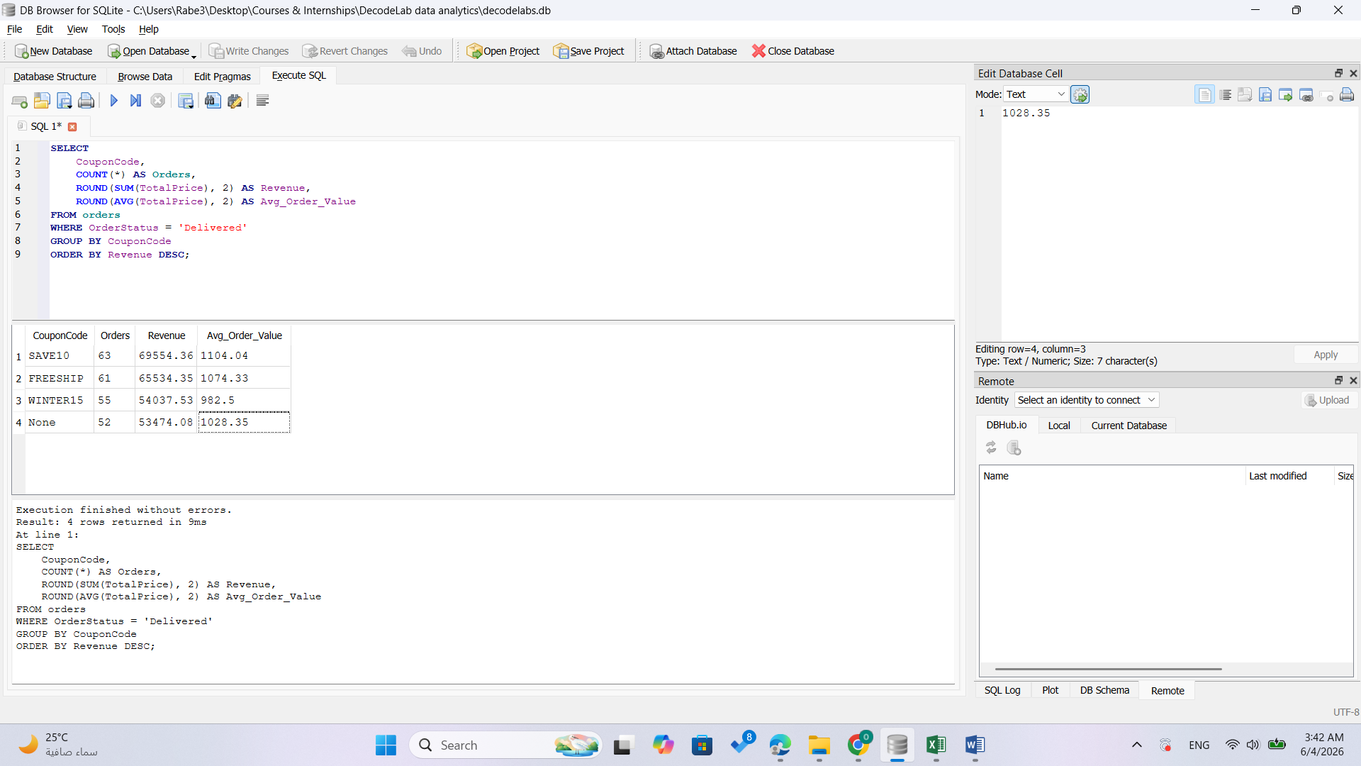
Table 7 — Referral Source Performance (Delivered Only)
ReferralSource | Total_Orders | Delivered_Orders | Revenue | Avg_Order_Value
Email | 250 | 60 | 64553.52 | 1075.89
Facebook | 228 | 42 | 52149.38 | 1241.65
Instagram | 259 | 52 | 51299.56 | 986.53
Google | 241 | 44 | 41406.25 | 941.05
Referral | 222 | 33 | 33191.61 | 1005.81
Comment: Email marketing produced the highest delivered-order revenue, while Facebook achieved the highest average order value per delivered order.
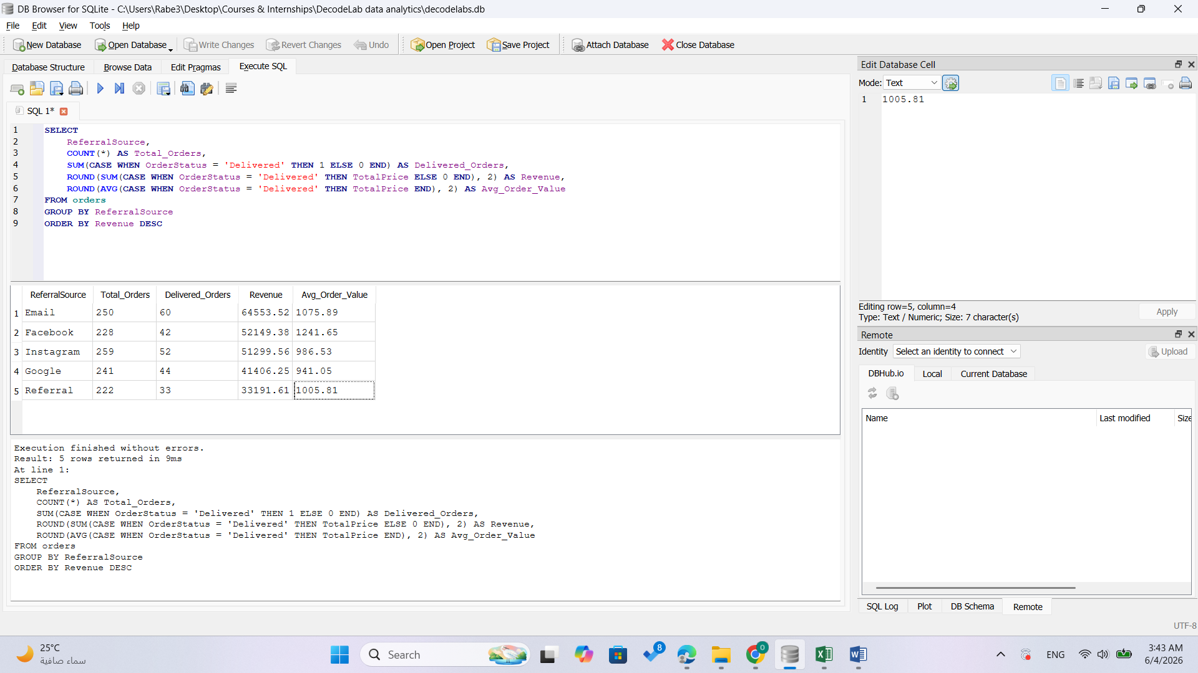
Table 8 — Top 10 CustomersTable
CustomerID | Number_of_Orders | Total_Spent | Avg_Order_Value
C38840 | 2 | 5723.23 | 2861.61
C57276 | 1 | 3456.4 | 3456.4
C67260 | 1 | 3390.8 | 3390.8
C13877 | 1 | 3384.9 | 3384.9
C18404 | 1 | 3370.2 | 3370.2
C16775 | 1 | 3353.75 | 3353.75
C65986 | 1 | 3352.4 | 3352.4
C47778 | 1 | 3334.0 | 3334.0
C59183 | 1 | 3322.55 | 3322.55
C25276 | 1 | 3313.9 | 3313.9
Comment: A small group of customers contributed substantially to sales, demonstrating the presence of high-value customers within the dataset.
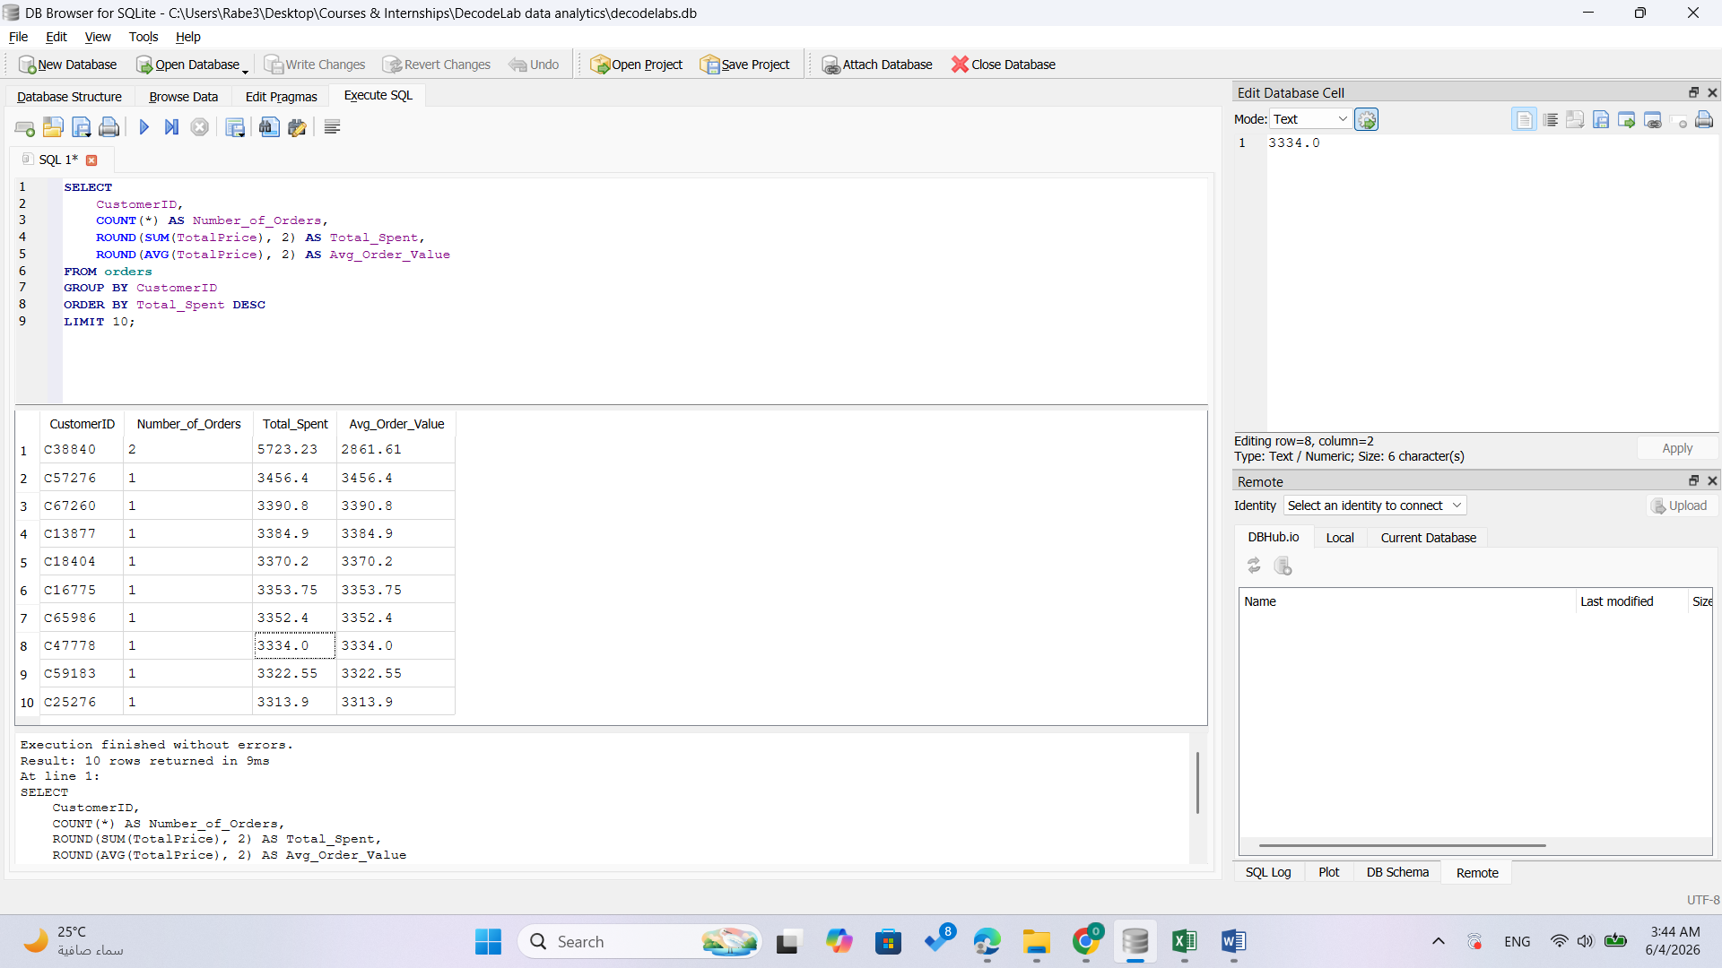
Table 9 — Coupon vs No Coupon Summary (Delivered Only)
Coupon_Usage | Orders | Total_Revenue | Avg_Order_Value
With Coupon | 231 | 242600.32 | 1050.22
Comment: Orders placed using coupons generated significantly more revenue than non-coupon orders, highlighting the effectiveness of promotional offers.
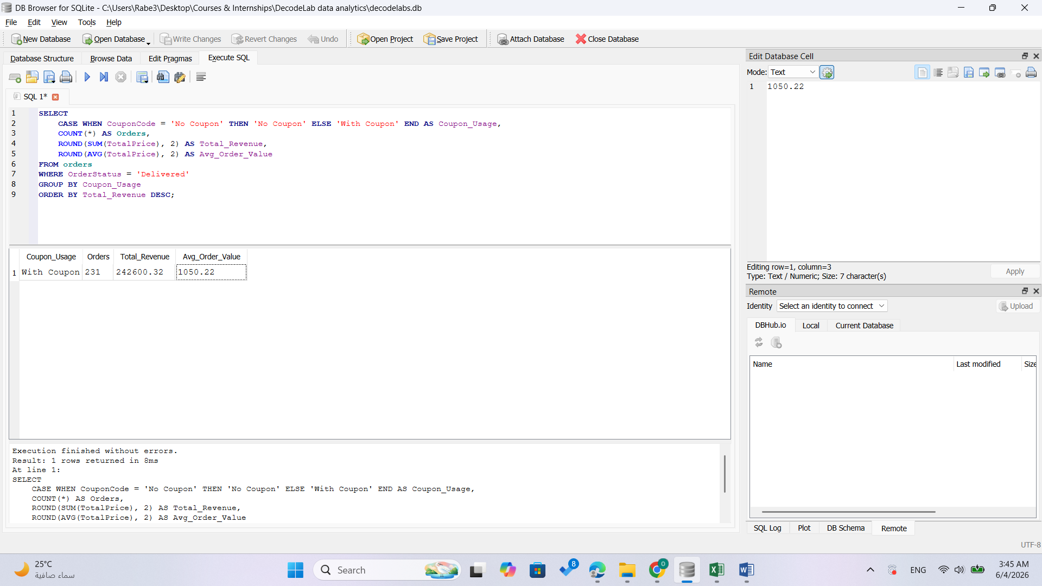
Table 10 — Max Unit Price per ProductTable 10 — Max Unit Price per ProductTable 10 — Max Unit Price per Product
Product | Max_Price | Min_Price | Avg_Price
Phone | 695.1 | 11.39 | 375.22
Tablet | 699.88 | 17.24 | 367.68
Monitor | 696.71 | 14.69 | 358.66
Laptop | 699.93 | 18.2 | 357.71
Chair | 695.29 | 14.93 | 355.66
Printer | 697.19 | 12.1 | 351.71
Desk | 697.93 | 26.95 | 329.61
Comment: Product pricing remains relatively consistent across categories, with maximum unit prices clustered around the same range.
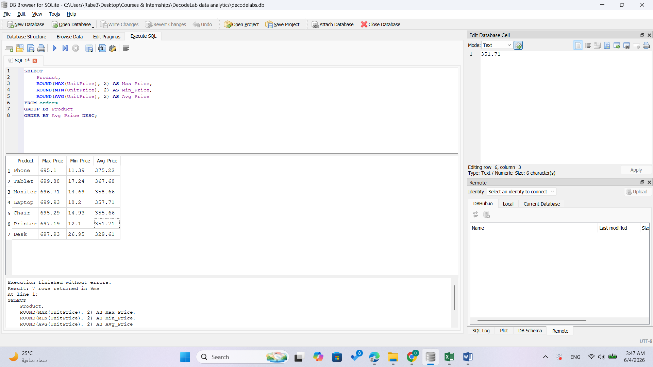
Conclusion
SQL was used to clean, aggregate, filter, and analyze the dataset. The results provide a concise overview of customer behavior, revenue patterns, product performance, and operational outcomes.

